Simultaneous EEG-fMRI

Contents

Step 2: denoise the EEG dataset 2

a) Load EEG dataset into python using mne 2

b) Remove gradient and ballistocardiogram artifacts (figure 3) 4

a. Use average artifact subtraction for both (Allen et al. 2000 see moodle) 4

c) Run ICA (figure 5) on EEG signal to isolate the alpha band components (figure 6) 5

a. can use the mne implementation of fastICA 5

d) Find the alpha band ICA components by visualizing the topography and power spectrum (figure 7). 6

e) Apply 8-13 Hz bandpass filter to alpha-band component(s) (to isolate alpha), rectify, and smooth. 8

a. There could be multiple components with good alpha, in that case, average them (after rectifying) 8

Step 3: denoise the fMRI dataset. The fMRI dataset must be motion corrected and bandpass filtered: 9

a) Load fMRI dataset into python using nibabel 9

b) Motion correct by registering every volume to the first volume 10

a. find some python library that can do this or create your own, can also do this using FSL or AFNI or some other external library (then load the corrected image in python) 10

c) Apply 0.01 – 0.1 Hz bandpass filter to the time series in each voxel 11

a. This will remove all frequencies outside 0.01 – 0.1 Hz 11

Step 4: combine datasets. After completing the pre-processing for both datasets (step 2,3) it is time to combine the datasets and get our final result: 11

a) Resample the smooth, rectified 8-13 Hz bandpass filtered component (step 2e) to 1 Hz (to match fMRI). 11

b) Correlate EEG alpha power (8-13 Hz) with fMRI in each voxel, yielding a 106x106x16 image where the value in each voxel is a correlation coefficient. 12

a. It might help to also bandpass filter the rectified, resampled EEG alpha between 0.01 – 0.1 Hz. 12

c) Show resulting correlation map overlayed on the T1 image (figure 8). 12

d) Perform cluster-based multiple comparison testing to eliminate spurious clusters 13

Dataset (from openneuro, if you choose to do the bonus) 13

# Step 2: denoise the EEG dataset

## Load EEG dataset into python using mne

In order to load EEG, I firstly did “pip install mne”.

MNE is minimum-norm estimate or minimum-norm estimation. MNE generate a distributed map of activation on a source space, usually on a cortical surface. It also uses a linear inverse operator to project sensor measurements into the source space.

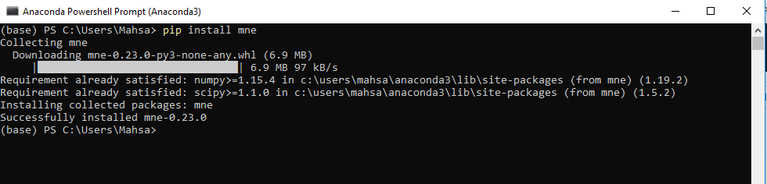

I was noticed that the 32th channel as ECG is not to be considered and I tried to remove it and get all of the rest 63 channels from 63 electrodes. After loading data into memory I got channel names by the aid of eeg.ch_names, I excluded bad channel as ‘ECG’ in this data and filtered it equal to 1 due to fMRI.

Then I just took 1o seconds from 332.920 and I assigned 1 to clipping in order to have more transparent plot.

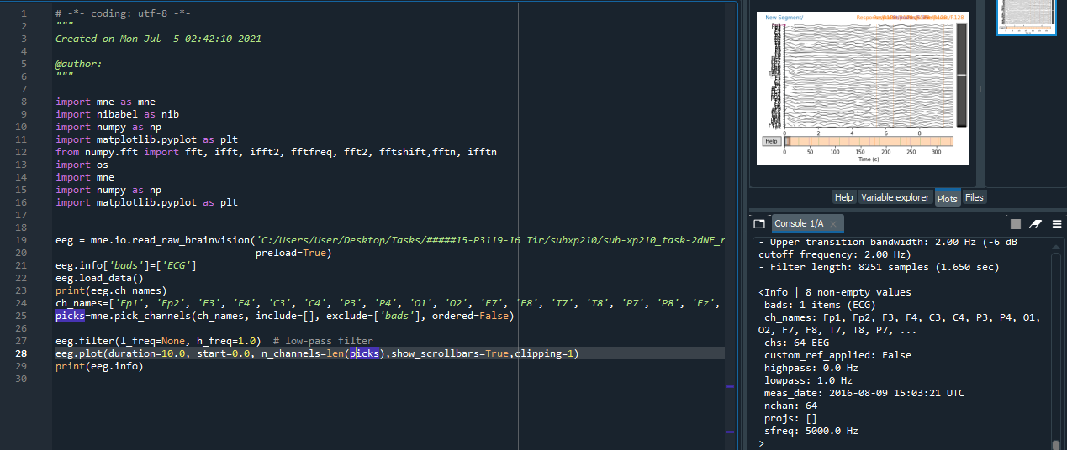

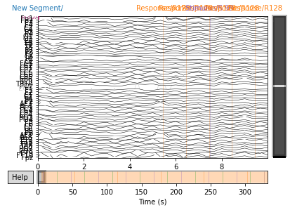

In the another plot, I decided to draw one channel from 64 channel and its name was “Fp1”.

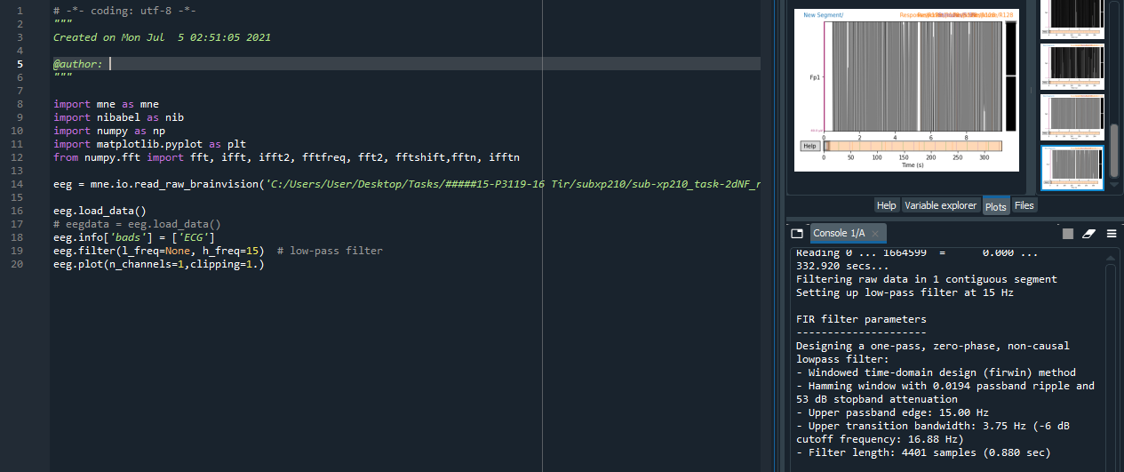

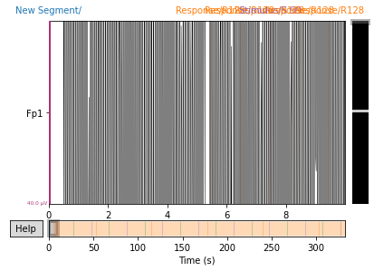

I changed frequency to alpha band which is between 8 to 13 Hz.

**mne.filter.resample(*x*, *up=1.0*, *down=1.0*, *npad=100*, *axis=- 1*, *window='boxcar'*, *n_jobs=1*, *pad='reflect_limited'*, *verbose=None*)**[**[source]**](http://github.com/mne-tools/mne-python/blob/maint/0.23/mne/filter.py#L1386-L1514)

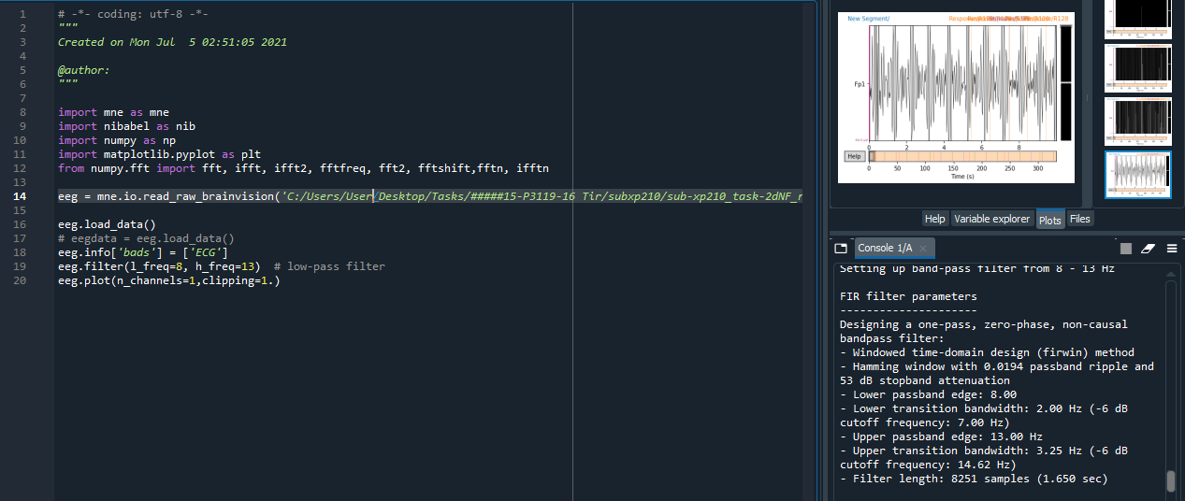

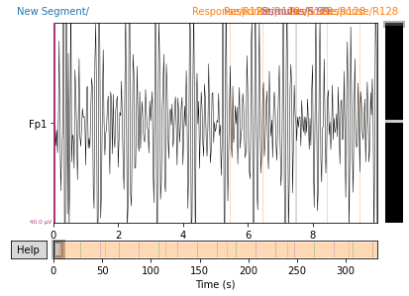

## b) Remove gradient and ballistocardiogram artifacts (figure 3)

### a. Use average artifact subtraction for both (Allen et al. 2000 see moodle)

In order to remove gradient I used reject parameter from mne.epochs and assigned grad=4000e-13 to remove gradiometers and for BCG or ballistocardiogram I got annotations and removed it from epoch by “reject_by_annotation=True”

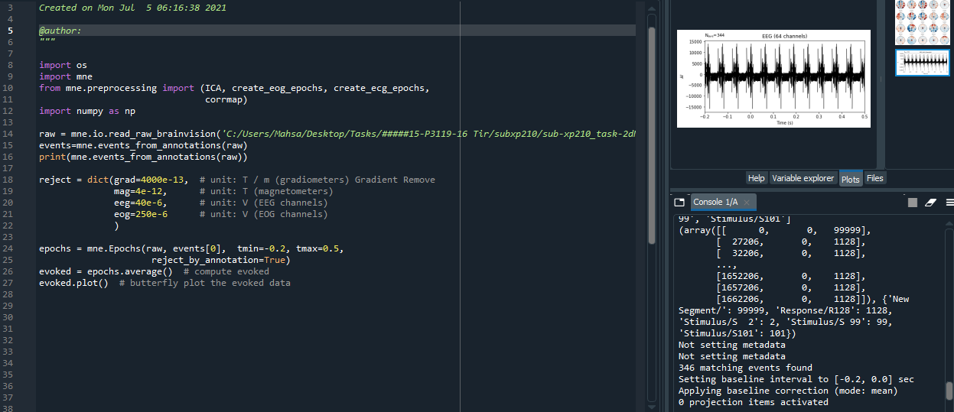

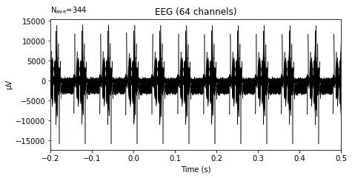

## c) Run ICA (figure 5) on EEG signal to isolate the alpha band components (figure 6)

### a. can use the mne implementation of fastICA

I tried to get events from mne.preprocessing and I pot epochs as follows:

Indeed Independent components analysis (**ICA**) is **used to** take a large data set consisting of many variables and reduce it into smaller number dimensions that can be understood as self-organized functional networks.

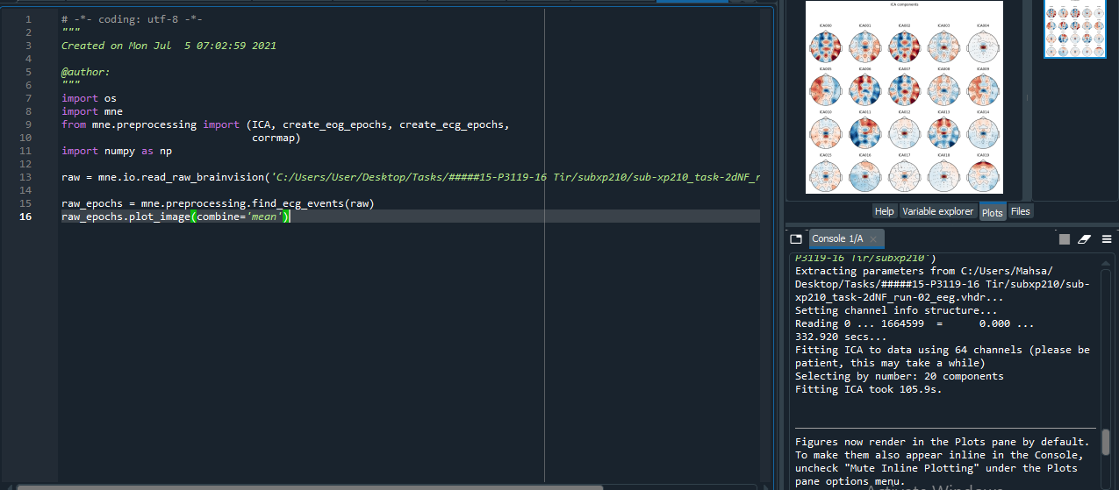

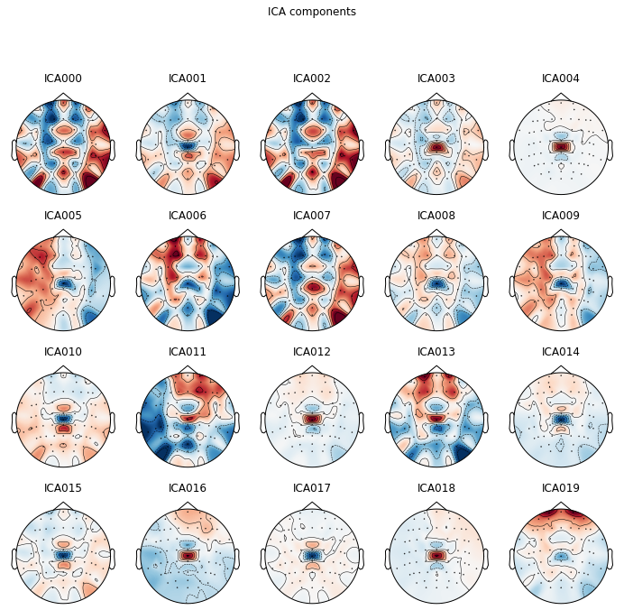

## d) Find the alpha band ICA components by visualizing the topography and power spectrum (figure 7).

Data decomposition using Independent Component Analysis (ICA).

This object estimates independent components from **[mne.io.Raw](https://mne.tools/stable/generated/mne.io.Raw.html" \l "mne.io.Raw" \o "mne.io.Raw)**, **[mne.Epochs](https://mne.tools/stable/generated/mne.Epochs.html" \l "mne.Epochs" \o "mne.Epochs)**, or **[mne.Evoked](https://mne.tools/stable/generated/mne.Evoked.html" \l "mne.Evoked" \o "mne.Evoked)** objects. Components can optionally be removed (for artifact repair) prior to signal reconstruction.

mne.preprocessing.ICA(*n_components=None*, *\**, *noise_cov=None*, *random_state=None*, *method='fastica'*, *fit_params=None*, *max_iter=None*, *allow_ref_meg=False*, *verbose=None*)

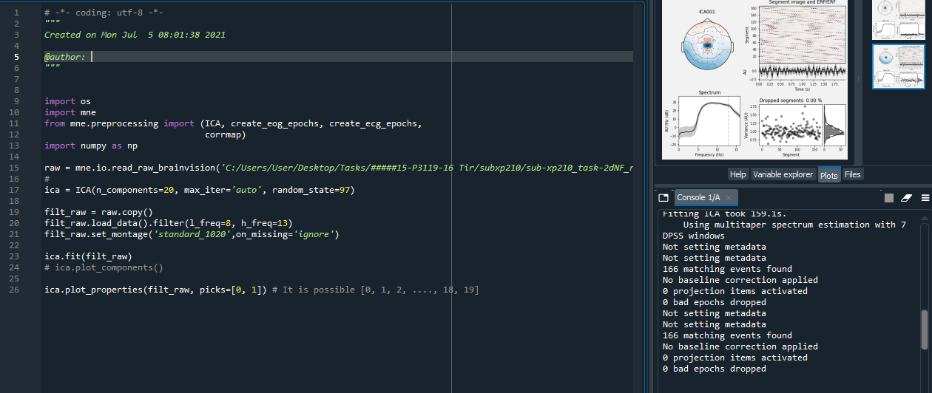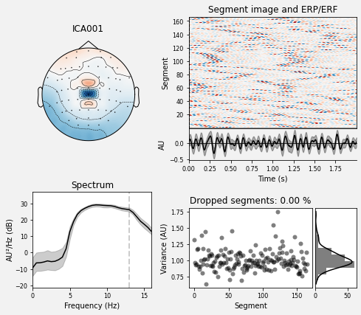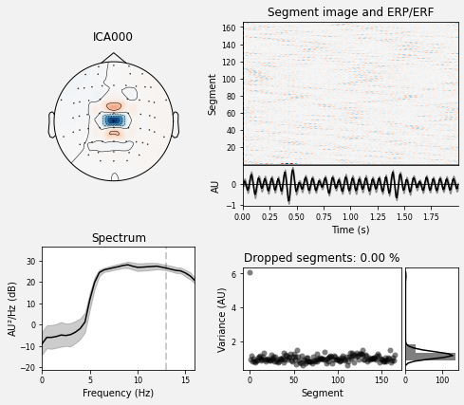

## e) Apply 8-13 Hz bandpass filter to alpha-band component(s) (to isolate alpha), rectify, and smooth.

### a. There could be multiple components with good alpha, in that case, average them (after rectifying)

I used raw.set_montage for having best parameters to detect sensor locations. Also for having more smoothing plot I used image_args={‘sigma’:1.]

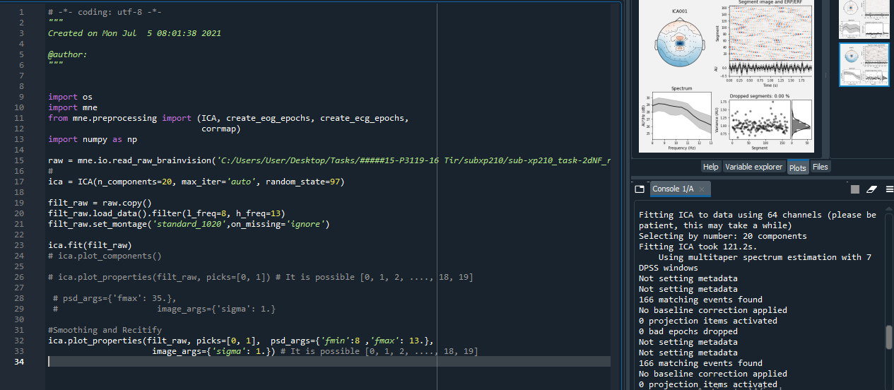

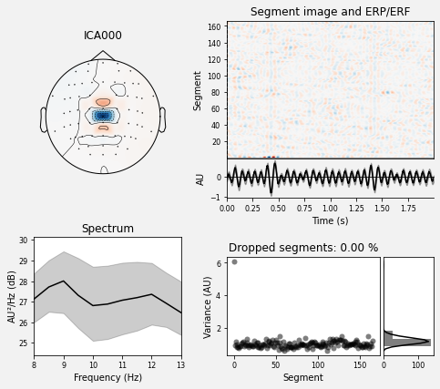

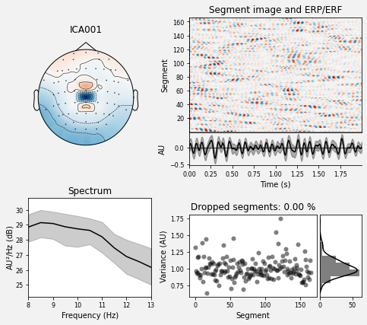

# Step 3: denoise the fMRI dataset. The fMRI dataset must be motion corrected and bandpass filtered:

## Load fMRI dataset into python using nibabel

I used nibabel to read nii files and I had to install nibabel into python, “pip install nibabel”.

In fact a nibabel (and nipy) image is the association of three things: 1. An affine array that tells the position of the image array data in a reference space. 2. Image metadata (data about the data) 3. describing the image, usually in the form of an image header.

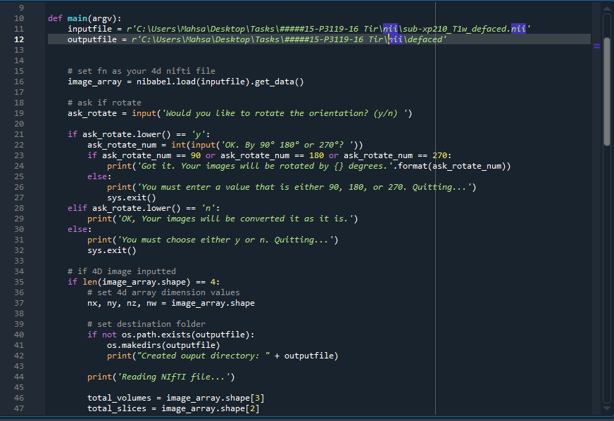

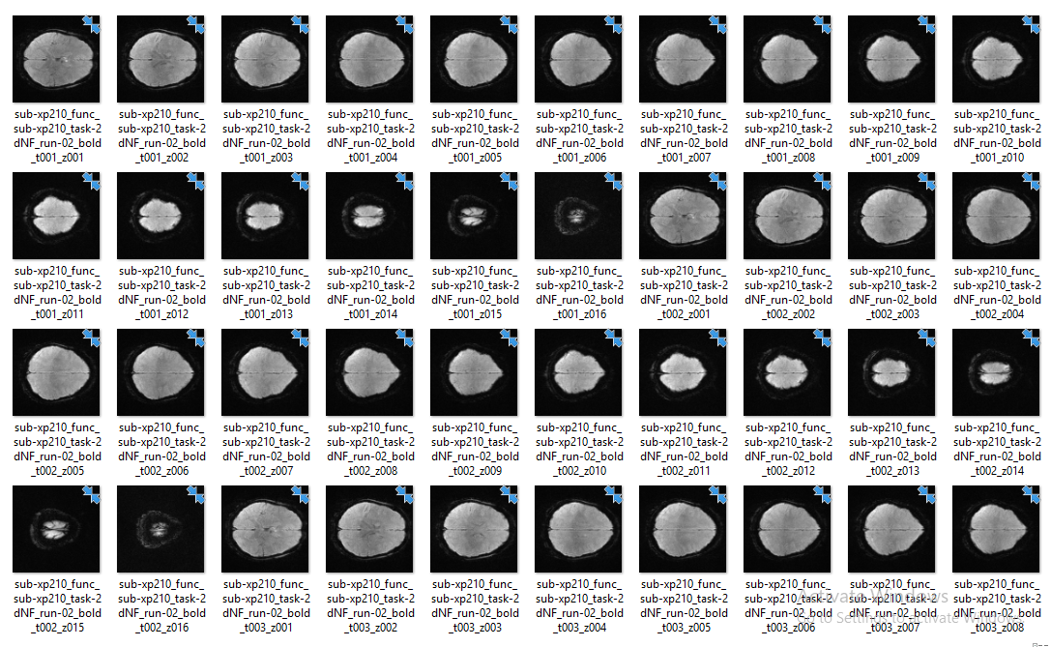

## b) Motion correct by registering every volume to the first volume

### a. find some python library that can do this or create your own, can also do this using FSL or AFNI or some other external library (then load the corrected image in python)

I used numpy.rot90 or nested numpy.rot90(numpy.rot90)=180 or numpy.rot90(numpy.rot90(numpy.rot90))=270 and asked from user to select how much degree is suitable to rotate and adjust image.

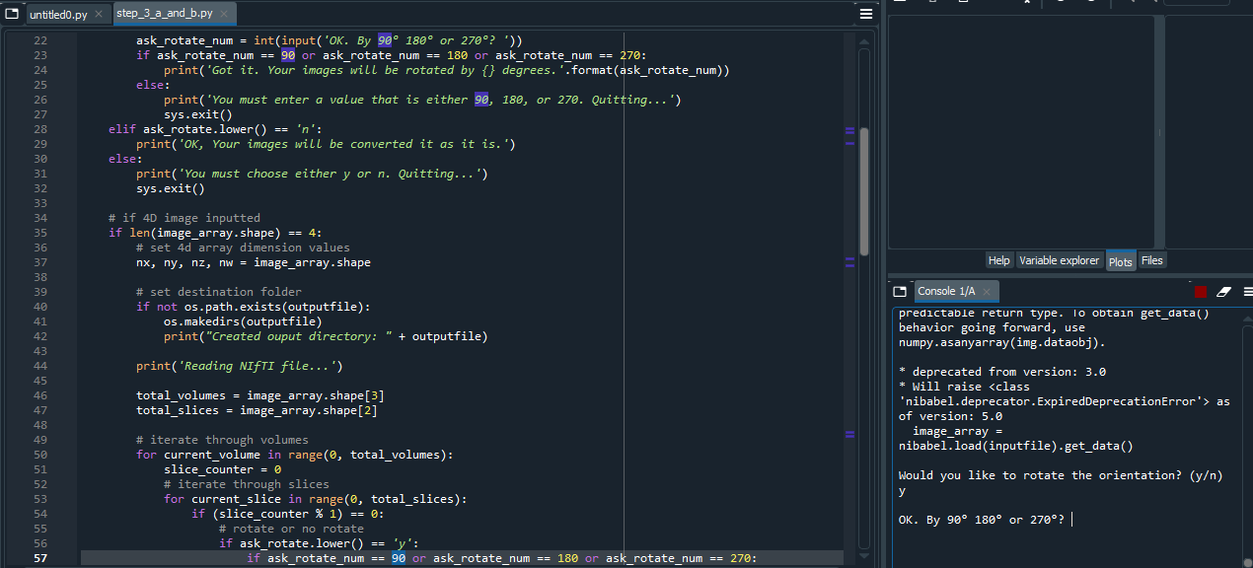

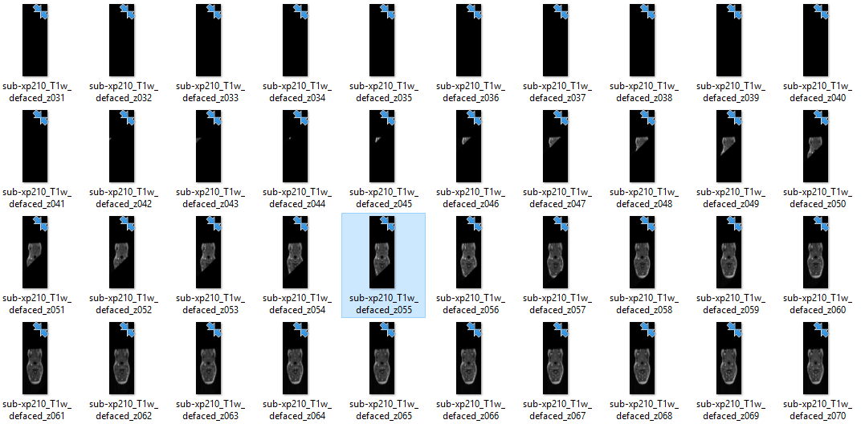

## c) Apply 0.01 – 0.1 Hz bandpass filter to the time series in each voxel

### a. This will remove all frequencies outside 0.01 – 0.1 Hz

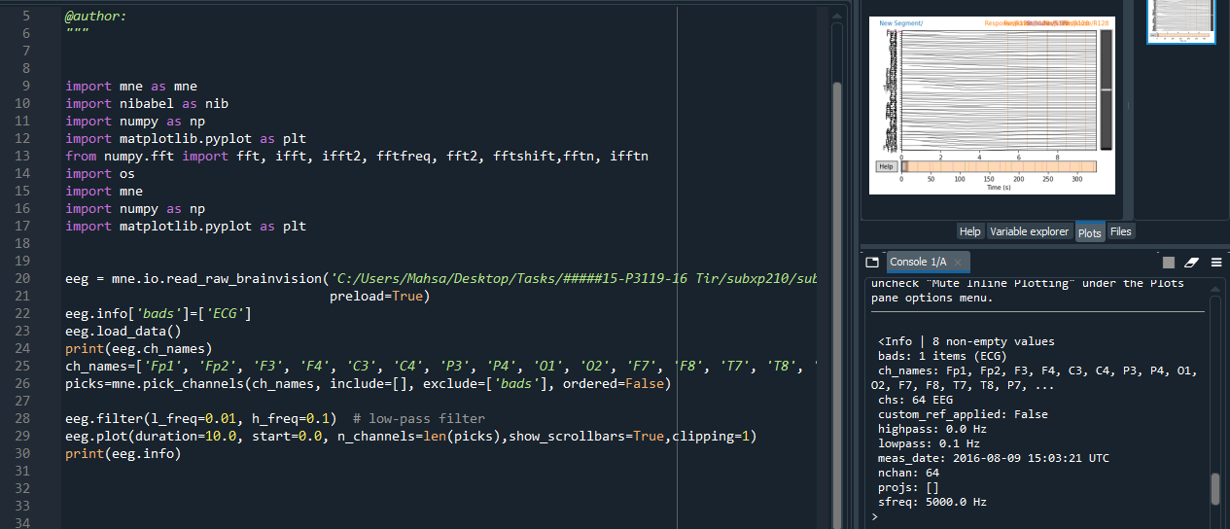

# Step 4: combine datasets. After completing the pre-processing for both datasets (step 2,3) it is time to combine the datasets and get our final result:

## Resample the smooth, rectified 8-13 Hz bandpass filtered component (step 2e) to 1 Hz (to match fMRI).

A filter removes or attenuates parts of a signal. Usually, filters act on specific frequency ranges of a signal — for example, suppressing all frequency components above or below a certain cutoff value. There are many ways of designing digital filters;

Artifacts that are restricted to a narrow frequency range can sometimes be repaired by filtering the data. Two examples of frequency-restricted artifacts are slow drifts and power line noise. Here I illustrate how each of these can be repaired by filtering.

[**raw.plot_psd**](https://mne.tools/stable/generated/mne.io.Raw.html#mne.io.Raw.plot_psd)

## b) Correlate EEG alpha power (8-13 Hz) with fMRI in each voxel, yielding a 106x106x16 image where the value in each voxel is a correlation coefficient.

### a. It might help to also bandpass filter the rectified, resampled EEG alpha between 0.01 – 0.1 Hz.

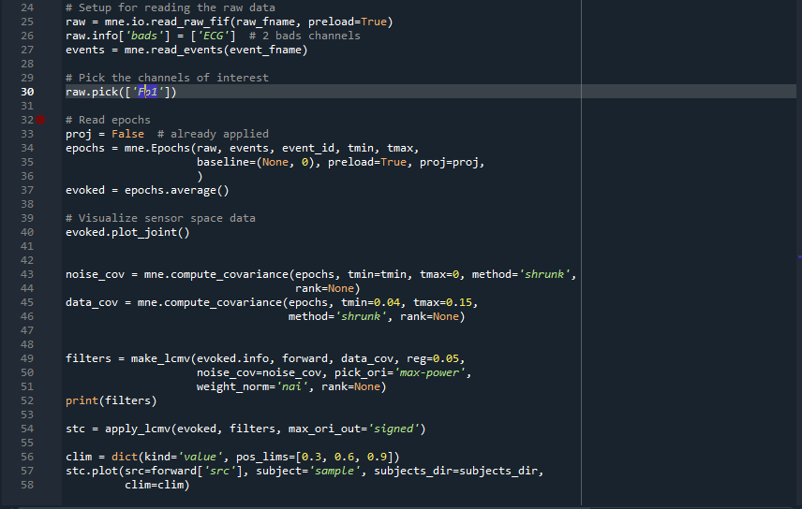

## Show resulting correlation map overlayed on the T1 image (figure 8).

It is the linearly constrained minimum variance (LCMV) beamformer [1](https://mne.tools/dev/auto_tutorials/inverse/50_beamformer_lcmv.html#vanveenetal1997) operates on time series. Frequency-resolved data can be reconstructed with the dynamic imaging of coherent sources (DICS) beamforming method [2](https://mne.tools/dev/auto_tutorials/inverse/50_beamformer_lcmv.html#grossetal2001). As we will see in the following, the spatial filter is computed from two ingredients: the forward model solution and the covariance matrix of the data.

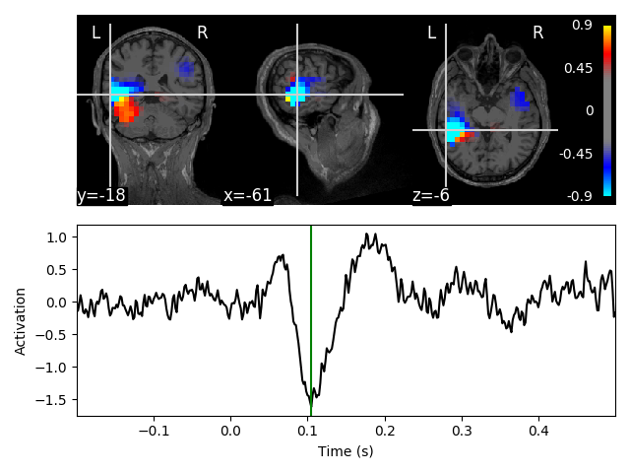

## d) Perform cluster-based multiple comparison testing to eliminate spurious clusters

Non-parametric between conditions cluster statistic on single trial power

This script shows how to compare clusters in time-frequency power estimates between conditions. It uses a non-parametric statistical procedure based on permutations and cluster level statistics.

The process contains of:

* extracting epochs for 2 conditions
* compute single trial power estimates
* baseline line correct the power estimates (power ratios)
* compute stats to see if the power estimates are significantly different between conditions.

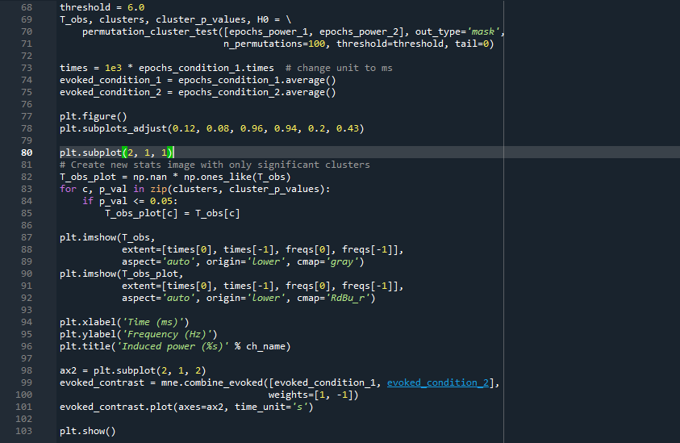

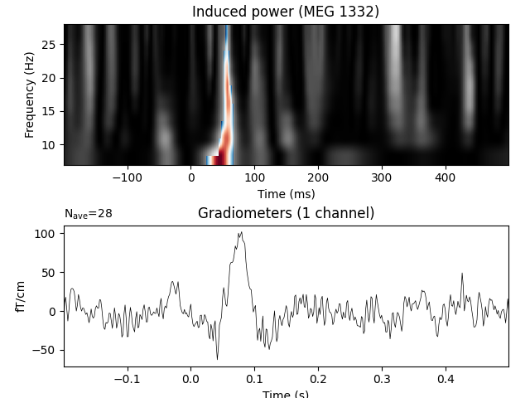

# Dataset (from openneuro, if you choose to do the bonus)

The problem for MNI standard brains is that the MNI linear transform has not matched the brains completely to the Talairach brain. This is probably because the Talairach atlas brain is a rather odd shape. Therefore, the MNI brains are slightly larger (in particular higher, deeper and longer) than the Talairach brain.

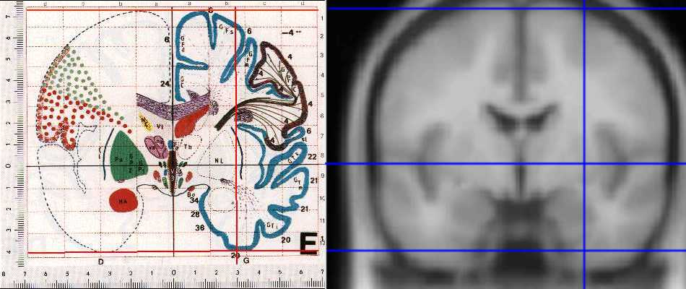

***Figure: Differences between MNI and Talairach***

[***https://imaging.mrc-cbu.cam.ac.uk/imaging/MniTalairach***](https://imaging.mrc-cbu.cam.ac.uk/imaging/MniTalairach)

There are two approaches in order to register:

1. To get from [McGill](https://imaging.mrc-cbu.cam.ac.uk/imaging/McGill) [MNI] -SPM96-coordinates to Talairach 88-SPM 95 coordinates:

X' = 0.88X-0.8

Y' = 0.97Y-3.32

Z' = 0.05Y+0.88Z-0.44"

1. non-linear transform of MNI to Talairach

This algorithm gave me the following transformations:

Above the AC (Z >= 0):

X'= 0.9900X

Y'= 0.9688Y +0.0460Z

Z'= -0.0485Y +0.9189Z

Below the AC (Z < 0):

X'= 0.9900X

Y'= 0.9688Y +0.0420Z

Z'= -0.0485Y +0.8390Z

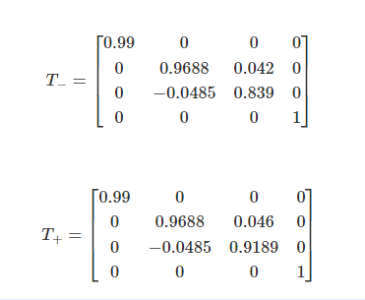

I have downloaded the rest parts of XP2 from xp201 to xp222.

